

**SEG 3101 PROJECT - DELIVERABLE 2**

Submitted

to

Wassim El Ahmar

By:

Group 22

Sami Hassan 3001691285

Uyen Nguyen, 300173303

Yi Yau Wong, 300241845

Tiana Ye, 300189296

Kristen Duong, 300240425

November 12, 2023

University of Ottawa

**TABLE OF CONTENTS**

**1.0 INTRODUCTION 1**

**2.0 DOMAIN DESCRIPTION 1**

**2.1 Glossary (terms and acronyms) 1**

**2.2 General Knowledge about the Domain 2**

**2.3 Environment and Context 2**

**3.0 INITIAL DESCRIPTION OF THE PROBLEM 2**

**3.1 Description of Stakeholders and their Goals 2**

**3.2 Description of the System Scope 4**

**3.3 Main Use Cases 4**

**3.4 Preliminary Requirements 6**

**3.5 Constraints 7**

**3.6 Risks 7**

**4.0 ASPECTS NEEDING CLARIFICATION 7**

**5.0 BACK TO INTERVIEWS 8**

# 

**LIST OF FIGURES**

**Figure 1 G.R.L. model describing the relationship between actors 3**

**and their goals**

**LIST OF TABLES**

**Table 1 Stakeholders and their goals 2**

**Table 2 User stories and their associated number 4**

**Table 3 System's preliminary requirements 6**

**Table 4 Team members and their contributions 9**

# 1.0 INTRODUCTION

The Graduate Admission Management System (GAMS) represents an innovative solution for streamlining and standardizing the graduate admission processes at the University of Ottawa. In response to the complex and time-consuming nature of current admission practices, GAMS offers an integrated platform that promises to bring efficiency, transparency, and fairness to the admission process. GAMS aims to improve the experience for both applicants and administrative staff.

In this second phase of the project, the development of GAMS is elaborated upon. By outlining the relations between the goals of the system and the stakeholders, the aim is to establish a clear understanding of the forces behind the development of GAMS. This report will explore the main use cases and present a G.R.L model depicting the relationship between stakeholders and their respective goals. Additionally, there will be a series of user stories that represent the core functionalities of GAMS and the system’s interaction with its users. Finally, a summary of an interview conducted with two stakeholders (an academic assistant and a graduate student) will be detailed. The objectives, accomplishments, and improvements for future interviews are further described.

# 2.0 DOMAIN DESCRIPTION

## **2.1. Glossary (terms and acronyms)**

**A**

**Admissions Committee**

The group responsible for evaluating and deciding on the admissibility of applicants.

**Alternative Offer**

An offer extended to students in the absence of a confirmed supervisor.

**C**

**Course/Project-based Program**

A graduate program without a thesis requirement involving coursework or project work.

**F**

**Faculty**

Academic divisions within the University offering various graduate programs.

**G**

**GAMS**

Graduate Admission Management System

**O**

**OUAC**

Ontario Universities’ Application Centre

**S**

**Supervisor**

A faculty member responsible for guiding and mentoring a student in a thesis-based

program.

**T**

**Thesis-based Program**

A graduate program requiring students to complete a thesis as part of their academic

requirements.

**U**

**uoCampus**

The University of Ottawa’s internal administrative platform.

**X**

**Xtender**

A web-based tool used for digitizing and storing student admission files and related documents.

## **2.2. General Knowledge about the Domain**

The system mainly serves in the domain of centralized application management. It receives all applicant applications and allows authorized parties access to this information for further processing. Many institutions use these types of software to manage new members' or employees’ applications. It streamlines the application process and allows more timely responses for applicants. These systems often integrate with other related systems, which in this case, is OUAC.

## **2.3. Environment and Context**

For the successful development, implementation, and usage of the Graduate Admission Management System (GAMS), it is essential to understand the environment and context in which it operates. The system is exclusively designed for the University of Ottawa, a multifaceted academic institution that comprises various faculties, programs, and administrative units. With its complex and diverse academic structure, the University of Ottawa represents a unique set of challenges that the GAMS must address to provide a comprehensive graduate admission and management system.

Defining the roles of stakeholders is a crucial aspect of any project. The system should be able to clearly outline the responsibilities, duties, and level of involvement of each stakeholder to ensure the project's success.

# 3.0 INITIAL DESCRIPTION OF THE PROBLEM

## **3.1. Description of Stakeholders and their Goals**

Table 1. Stakeholders and their goals.

| **Stakeholder** | **Goal** |
| --- | --- |
| Student | To be able to search for and apply to suitable graduate programs and receive admission decisions from the office. |
| Academic Assistant | To process applications by allocating them by program, calculating admission average, and making sure the applications get sent to appropriate parties. |
| Associate Director and Committee | To evaluate the admissibility of students using evaluation templates designed for the respective faculty. |
| Faculty’s Manager | To uphold the integrity and accuracy of admission decisions and communicate these decisions to the students |
| Professors | To easily access and review applicant information for potential supervision of the student in thesis-based programs |

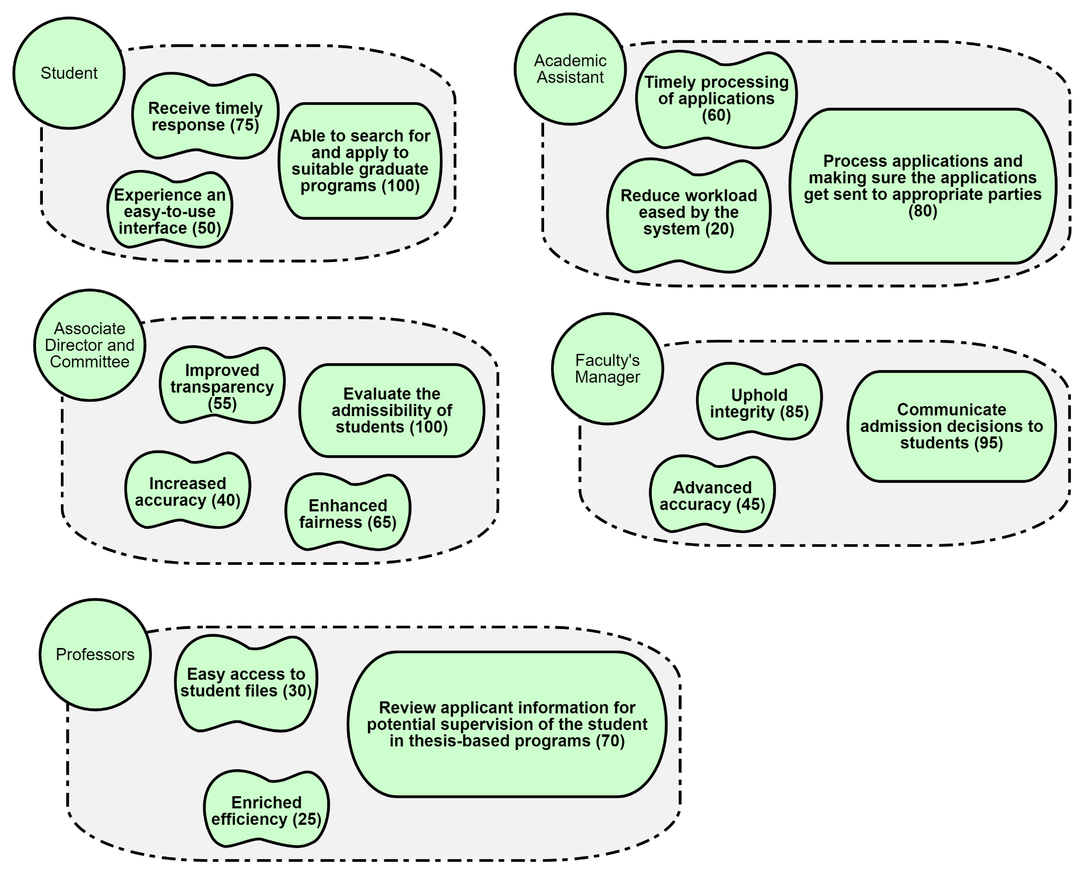Figure 1. G.R.L. model describing the relationship between actors and their goals.

## **3.2. Description of the System Scope**

The main goal of GAMS is to manage the graduate admission process at the University of Ottawa. This application will provide a centralized and efficient system for managing admissions, applications, evaluations, and recommendations. This system will help reduce the time of manually processing applications, minimize delays, and enhance overall efficiency and effectiveness.

GAMS stakeholders, those involved in using the system, include students, academic assistants, associate director and committee, faculty manager(s), and professors.

GAMS will allow the applicants to submit their application online with the Ontario Universities Application Center (OUAC). All the applications of each program will be arranged automatically by the system when the associate director completes the grade calculation. GAMS will also integrate with Xtender to manage the applicants’ records. There will be a search engine that makes the search easier for applicants when accessing the system. Also, GAMS will include a mechanism for assigning supervisors to students in thesis-based programs, with provisions for managing cases where a supervisor is not known. To verify the application, there will be a verification process per application for the faculty's manager. The system then automatically sends confirmations to applicants via uoCampus. At the same time, the system will define and enforce an amount of time for applicants to either accept or reject their offer. GAMS will allow for customization to accommodate variations in admission processes across different graduate programs within the University.

By defining these features, the system scope of GAMS is expected to reduce the challenges and achieve better operation in the admission process.

## **3.3. Main Use Cases**

Table 2. User stories and their associated number.

| **Story Number** | **User Story** |
| --- | --- |
| 1 | As a Student, I want to receive an email confirming the acceptance of my application so that I can proceed with the next steps. |
| 2 | As a Student, I want to be able to save a draft of my application so that I can continue working on it should I be interrupted. |
| 3 | As a Student, I want to be notified when a supervisor has been assigned to me so that I have a professor to supervise my thesis. |
| 4 | As a Student, I want to receive notifications about any changes made to the status of my application so that I am kept up-to-date. |
| 5 | As a Student, I want to receive an email receipt once my payment has been processed so that I ensure my application can be processed. |
| 6 | As a Student, I want to be reminded of an expiring offer within three working days of the date so that I do not miss out on a graduate program. |
| 7 | As a Student, I want to be considered for an alternative offer if I do not find a supervisor so that I can still pursue graduate studies. |
| 8 | As an Academic Assistant, I want to receive an automatically calculated admission average of an applicant so that I can avoid potential errors. |
| 9 | As an Academic Assistant, I want to be able to ignore applications with a GPA less than 7.0 so that I can save time on manual review. |
| 10 | As an Academic Assistant, I want applications that meet the GPA requirement to be sent to a Dropbox directory once reviewed so that the Academic Committee can evaluate the applications. |
| 11 | As an Academic Committee Member, I want to evaluate and verify the same number of applications as other committee members so that the workload is fair. |
| 12 | As an Academic Committee Member, I want to be notified when an application I have evaluated is being verified by another committee member. |
| 13 | As an Associate Director, I want to evenly distribute applications among committee members so that there is a fair evaluation process. |
| 14 | As an Associate Director, I want evaluated applications to be automatically moved into different Dropbox depending on the decision made so that I can keep a record of the year’s applications. |
| 15 | As a Professor, I want to be able to have access to a Student’s contact information so that I can communicate funding for their thesis. |
| 16 | As a Professor, I want to be able to receive a list of eligible students who have yet to find a supervisor so that I can consider supervising their thesis. |
| 17 | As a Professor, I want to be able to contact an eligible student on the list who I am interested in supervising so that they can find a supervisor for their thesis. |
| 18 | As a Hacker, I want to be able to delete student applications so that I can increase my odds of getting accepted into a graduate program. |
| 19 | As a Hacker, I want to be able to gain access to the GAMS database so that I can sell the data for financial gain. |
| 20 | As a Hacker, I want to be able to steal a user’s password so that I can get access to their personal data. |

## **3.4. Preliminary Requirements**

When developing the system, it is important to detect and resolve conflicts among the various requirements. Additionally, it is necessary to identify any limitations of the application and how it will interact with the organization and its operating environment. To achieve the desired outcome for this application, it is important to establish clear preliminary requirements needed for development.

Table 3. System's preliminary requirements.

| Requirements | Stakeholders | Goal Alignment | Conflicts |
| --- | --- | --- | --- |
| Encrypt personal information according to data integrity standards | All Users | Ensure data security and privacy | Security concern |
| Applicant must be able to submit their application through OUAC | Students | Makes the task of submitting an application straightforward and less complicated | Making it compatible with the current system |
| Applicants can search and select certain graduate programs | Students | Allows applicants to easily find programs | Flexibility |
| Students must receive admission confirmation documents via uoCampus with email notification | Students | Update the status of the application(s) | Communication with different cases |
| Academic assistants must be able to access and review assigned applications | Academic Assistant | Ensures efficient allocation and processing of applications | Adaptability |
| Automated calculation tool | Academic Assistant | Booster evaluation process | Many calculations with different criteria |
| Admission committees have access to program-specific evaluation processes | Associate Director and Committee | Facilitates consistency in the review process | Workflows |
| Receive applications based on faculty preferences | Professor | Standardize evaluation processes | Evaluation and supervision |
| To efficiently match students with their aligned thesis interests | Professor | Matching process | Flexibility and availability |

## **3.5. Constraints**

There are constraints related to time and cost. The fixed budget and operational deadline may make the development of the system less flexible. When the deadline is set too close to the present date, it adds pressure to the development team and it can greatly cost the quality of the system. With less financial support, there will be less personnel available to work on the system. Therefore, it constitutes one more constraint as less skillful people working on the system will result in a negative impact on the system.

Furthermore, there are technical constraints to be considered. For example, if a newly hired developer is not skilled in the current programming environment, it takes time to train them. Also, when it is peak hour, the system may not be able to handle the high volume of users.

## **3.6. Risks**

1. A major risk to the project could be being too ambitious with the requirements of GAMS. Certain requirements could be wishful thinking, there will always be potential for unforeseen circumstances to occur that do not respect the requirements established. An example of this could be an availability requirement of the system, having the uptime of the system be a high percentage of time. If unforeseen circumstances cause a system outage for a long period, the requirements will not be respected. The system’s requirements should be realistic to ensure the stakeholders are satisfied with the system.
2. Another major risk to the project could be the budget and cost of the project. When developing an initial prototype for the system, the number of features and requirements should be limited. Stakeholders can make use of these prototypes so they can have a visual reference of the system and can provide feedback and improvements that will meet their goals. However, this may require multiple prototypes to be created with more detail being added, causing issues with time and budget.
3. Additionally, a third major risk involves the scope of the system and frequent changes in requirements throughout the project. Stakeholders might introduce new features or modifications, expanding the project scope beyond what was initially envisioned. These continuous changes to the project can significantly impact timelines, budgets, and the overall direction of the system. It is important to balance stakeholder expectations and realistic features and modifications to prevent going beyond the scope.

# 4.0 ASPECTS NEEDING CLARIFICATION

There are currently no aspects needing clarification.

# 5.0 BACK TO INTERVIEWS

For this interview, the objective of the interviewers was to gain a better understanding of the University of Ottawa’s problem domain and how its current process is being carried out regarding student applications. Knowing these two topics will help in understanding the scope of the development, what features the interviewees prioritize most, and overall, how their goals can lead to a successful deployment. Interviewers met with two stakeholder groups, specifically those who review the applications (having 2+ years of experience), as well as those who have applied to graduate programs and are current graduate students at uOttawa. Interviewing these stakeholders allowed for the perspective of those on the front end and see how they think (their knowledge). In return, the interview process benefits these stakeholders as they have a chance to voice their opinions and speak about their experiences.

The objectives were met through our active listening during the interviews. In the beginning, the questions asked were open-ended, probing for varied responses based on personal experience. Following would be detailed questions based on their response to gain more information on their reasoning. That being said, for many of the questions, interviewees responded with their stated requirements, which were explicit, however, while those details were considered,interviewers also knew to listen for underlying intents. By paying attention and showing empathy to the interviewees’ implicit feelings and needs, interviewers were able to differentiate between the stakeholders' stated requirements and their actual requirements. Their unstated information provided the information to better understand how to develop an application that reviews and processes applications, as well as one that graduate students could easily use to apply to programs. After thanking the interviewees to conclude, a close connection was established and two rewarding perspectives to analyze were gained.

While the objectives were met, there are improvements to make for future interviews. During the interview, active listening and writing minimal notes was a way to build the relationship with the stakeholders; through speaking and responding to their answers. However, having a notetaker to detail information that may have been missed in passing would have been beneficial. Having comprehensive written notes would have helped when returning to the notes to recap the interview. Interviewers could have also expanded on some factors/features they may have missed. To add to that, this would also include some whiteboard drawings done but erased to make space for new ones. If able to return to those erased sketches, those ideas could have been built on further rather than scraping them. A final improvement would be to allocate more time for the interview. As there were multiple questions and ideas talked about throughout the meeting, it was found that towards the end, the interview had to be rushed to get an answer for all questions. Therefore, having an additional 30 minutes to the existing hour meeting would make for a better interview experience.

# 6.0 DESCRIPTION OF TEAM AND ROLES

In the table shown below are the tasks performed by each team member. Each member was in charge of a specific section/sub-section

Table 4 . Team members and their contributions.

| Team Member | Tasks Contribution |
| --- | --- |
| Kristen Duong | 4, 5, Appendix A |
| Sami Hassan | 3.3, 3.6 |
| Tiana Ye | 1, 2.1 |
| Uyen Nguyen | 3.2, 3.4, 2.3 |
| Yi Yau Wong | 3.1, 3.5, 2.2 |

# 

# APPENDIX A: INTERVIEW NOTES

The following questions are what was asked of each interviewee. Questions were asked in the order listed below. Underneath each question is a summary of the stakeholders' answers and any notes created during the interview.

1. **How many graduate programs do a single applicant usually apply to at the University of Ottawa yearly?**
   1. **In which month(s) of the year do you receive the most applications?**
   2. **Where are these applications primarily coming from? Are these Canadian students or international? If international, which countries are they applying from?**

*Academic Assistant Response:* It has been noticed that most applicants tend to apply to 3-5 different programs here at the University of Ottawa (with all programs within the same faculty). For example, if an applicant’s undergraduate was in computer science, they may apply to programs specializing in artificial language, cyber security, or database systems.

(a) All applications are submitted to OUAC at least a year before the applicant plans to begin their graduate studies. The majority of students apply in mid-November to ensure that they receive their results before the beginning of the fall term.

(b) From the applications received, the main subset is from various regions in Canada, primarily Ontario and Quebec residents. Internationally, China and France are the top 2 countries. This comes as no surprise to the academic assistants considering Ottawa is a bilingual community and has a large community of Chinese speakers.

*Previous Applicant Response*: Having been a Canadian-born, Chinese-raised who learned to speak French in school, this past applicant applied to the University of Ottawa under 3 different, yet similar programs. They studied Software Engineering as their undergraduate program and wanted to expand their knowledge in either machine learning, computer architecture, or software requirements engineering. As they had an interest in each and wanted to ensure they were accepted into the university, they applied to various programs. They planned to begin studying in the summer term, therefore, they began the application process in January of the previous year.

1. **What is the standard procedure an academic assistant follows to determine whether an application is accepted or declined?**
   1. **Depending on the program the applicant is applying to, do these standards change?**

*Academic Assistant Response:* Each faculty has a different standard to abide by. To accommodate the different programs and their requirements, academic assistants need to be able to perform various tasks, such as opening/downloading and reading/printing applications and marking, in a form, what fields an applicant passes/fails. These fields vary from program to program. However, from that, they can determine the admissibility of an application. Apart from those, every program also has the rule that a student’s academic average must be at least a CGPA of 7.0. To calculate this, assistants consider the last 20 courses for a master's degree or the last 10 courses for a doctorate.

1. **What is the average time it takes for you to determine/calculate an application’s next status?** 
   1. **When reviewing these applications, were there specific things you looked at first to shorten your work time?**
   2. **Is there a period you have to complete reviewing these applications?**

*Academic Assistant Response:* The majority of academic assistants marking applications tend to take 1 ½ hours-3 hours. The hours range depending on the program and application letter length. For example, those applying to the Faculty of Science have formal and long applications, while those in Arts may have a portfolio of their art and can include a short letter.

(a) If an application was submitted as a Word document, or any other text document, academic assistants must refuse to mark those as they are not in the proper format required (PDF). Regarding the application itself, if there is not a clear thesis or the formatting of the application is incorrect, assistants reject it. That being said, if a submission does not include a cover letter, a title page, a table of contents, and proper headings and paragraph separation, an application will not be accepted.

(b) The period academic assistants review applications is during their work hours. This ranges from 8 am to 5 pm on weekdays. The academic assistants have at max. 2 months to accept or reject an applicant from the moment they receive them.

1. **From the current resources you are provided by the university to review an application, are there any that you like?**
   1. **Were these tools easy to learn when you were first introduced to them?**
   2. **Is this something that helps you work or do you consider it an unnecessary step?**
   3. **Why do you consider these tool(s) to be useful or useless?**

*Academic Assistant Response:* Of the current resources provided by the university, Xtender is a favourite among many academic assistants. They find the tool to be simple enough for non-technical assistants to use and reliable as it has never failed while being used. There are not many buttons or instructions to follow and each step is direct and fast-loading. Many new trainees pick up on the tool quickly and since there is a public user guide, using the tool has never caused any trouble. As the tool is used almost every day by academic assistants, this is a very important step in the overall application process as it can digitize and centralize student applications/documents.

*Notes from the interview:*

* Xtender’s user guide can be found on uOttawa’s website.

1. **When assessing a student’s admissibility, which facilities did you consider to have a reliable and comprehensible process, or otherwise?**
   1. **What made these facilities stand out from others?**
   2. **Is there anything you would change from this facility’s process?**

*Academic Assistant Response*: When reviewing applications for the Faculty of Social Sciences, many reviewers have mentioned the ease of the automation this faculty provides over any other. The integrated system they have in place was efficient in accepting/rejecting applications and processing a student’s admissibility into the graduate program. There were also no complicated or redundant steps as the system performed these tasks for the user. There is no specific feature they recommend making/changing and express hope that the system continues to perform the same.

*Previous Applicant Response*: After applying to the Faculty of Engineering themselves, they have found that the process is tiresome and repetitive. There are multiple forms to fill out which could have been automatically filled out based on previous documents uploaded and questions the applicant filled out prior. This slow and tiresome process has caused many deadline delays by those reviewing engineering applications. Therefore, a big feature this stakeholder wishes to happen: automating form completion by having the computer read uploaded document information.

1. **How do Associate Directors receive successful applications?**
   1. **How do you communicate with them?**

*Academic Assistant:* Successful applications are communicated to Associate Directors through their school email.

1. **For the programs that require a supervisor, is there a generic email you send to professors to find supervisors?**
   1. **What is the time frame you give to these professors to respond?**
      1. **What is the time frame you give to applicants to find a supervisor (if a supervisor is known)?**
   2. **How do you keep track of the applicants who successfully/unsuccessfully find a professor?**

*Academic Assistant:* There is a generic template used to send emails to professors when a student does not have a supervisor. However, assistants must manually copy/paste the list of applicants into the template each time and manually type each professor's email in the sending list. The time frame given to professors to respond is two weeks. When an applicant successfully finds a professor, the professor sends an email reply back and the assistant must go into the student’s and professor’s records, and mark it in the system themselves. Likewise, if they do not find a professor.

*Previous Applicant Response:* Students who are unable to find a supervising professor must contact available professors themselves. The contact list can be provided by asking an academic assistant. However, if a student is unable to find a professor after 2 weeks, they would contact the academic assistant and an exception could be made depending on the student’s academic standing and effort towards finding a professor.

1. **For the deployment of GAMS to be successful, what would you consider first?**
   1. **Is there a reason why these features stood out from others?**

*Academic Assistant:* Whether the system performs its tasks within ~5 seconds. This is important as many manual and repetitive tasks assistants currently encounter can take anywhere between a couple of minutes to hours. Having a system that can efficiently automate many current manual tasks would reduce the time taken to accept/reject applications.

*Previous Applicant Response:* Receiving updates on their application is considered to be their most important feature. The past system would only send a notification once their application had been marked, however, knowing when their application was received by the university, when it began being looked at, and when the final verdict has been made, are all aspects a student should know. Staying informed of this information helps ease the anxiety and stress of the applicant and keeps them updated in real-time.

1. **Based on how the previous questions were answered, here is how we would prioritize these features, from most important to “nice to have”. Do you agree, if not, which ones would you change and why?**

*Note written by interviewers in the meeting:*

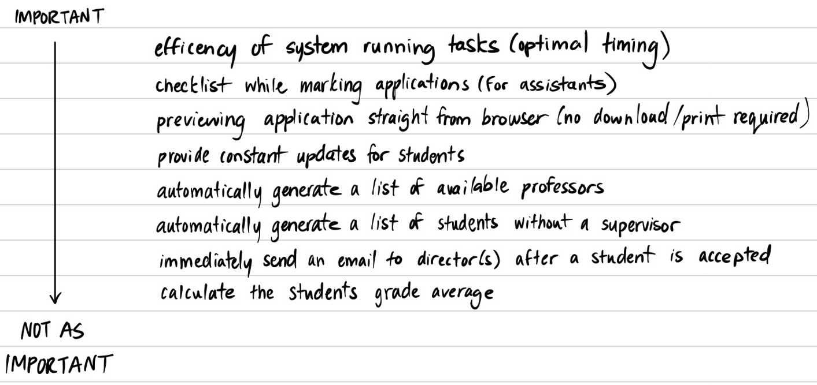

*Response From Both Stakeholders:* Rather than immediately sending an email of those accepted to the Associate Director, once all applications have been reviewed and a list has been generated, then a single email should be sent with all names compiled in a file. This is to prevent spamming. Also, calculating a student’s grade average should be slightly higher (middle) as this process is repetitive and prone to calculation mistakes, whereas a computer is more reliable (possibility of human error).

The rest of the features in their current order are acceptable.

1. **Do you have any concerns with the objectives we’ve set for this interview? If so, is there any other topic you would like to mention that you believe we should take into account?**

*Response From Both Stakeholders:* There are no concerns regarding the objectives made for the interview.

1. **If this interview was an open group meeting to discuss GAMS, who do you think should participate in this meeting apart from the people in this room?**
   1. **What made you choose these people?**

*Response From Both Stakeholders*: A university survey could be held and sent to all applicants, successful and not, and ask for their feedback and opinion on the current application process and what they think should be improved. Also having professors who supervise graduate students, an associate director and someone from the committee to provide input would be beneficial as they are also people who have access to a student’s information and application. Therefore, as users of GAMS, their advice would help from another perspective than those reviewing and applying.

**GUI Elements:**

From the interview, listed below are the GUI elements that were mentioned to include in GAMS for a successful deployment:

* Have pages with forms that allow a user to fill out various fields
  + Include check boxes, comment boxes, and text fields to allow for user input
* Include a screen to display PDF applications
  + Have a button to allow for downloading the PDF
  + Implement Xtender as a 3rd party tool to digitize and store student admission files and related documents in one place
* Have a pop-up message after a student receives their admission status asking them to perform a survey for future improvements